Roses in 7C Case Study

Customer

The customer is a large producer of cut roses and propagate their own rose plants as well as propagating for other growers. The challenge was to find a high quality, reproducible growing medium which did not vary between batches and year on year. In addition, the client required ease of use and specific features such as quick rooting, a good tray system, easy transportability and very importantly, ease of transplant.

Trial period.

The client has used the Jiffy 7C pellet for many years and has experimented with various sizes. The pellet size settled on was the 50mmx60mm pellet as it gave sufficient size to keep the cutting in the nursery for the required time while allowing sufficient room for root growth. Currently, the client is conducting ongoing trials with the 40mmx60mm pellet and results are promising. This would mean a decrease in price per plant for the customer as well as improved usage of space in the nursery, while still providing the plants with the room to develop sufficient rooting.

A number of tray systems have also been trialled and currently the Jiffy 50mmx45 cavity tray (deep tray) is being used. The depth of the tray is important in retaining moisture and encouraging root growth.

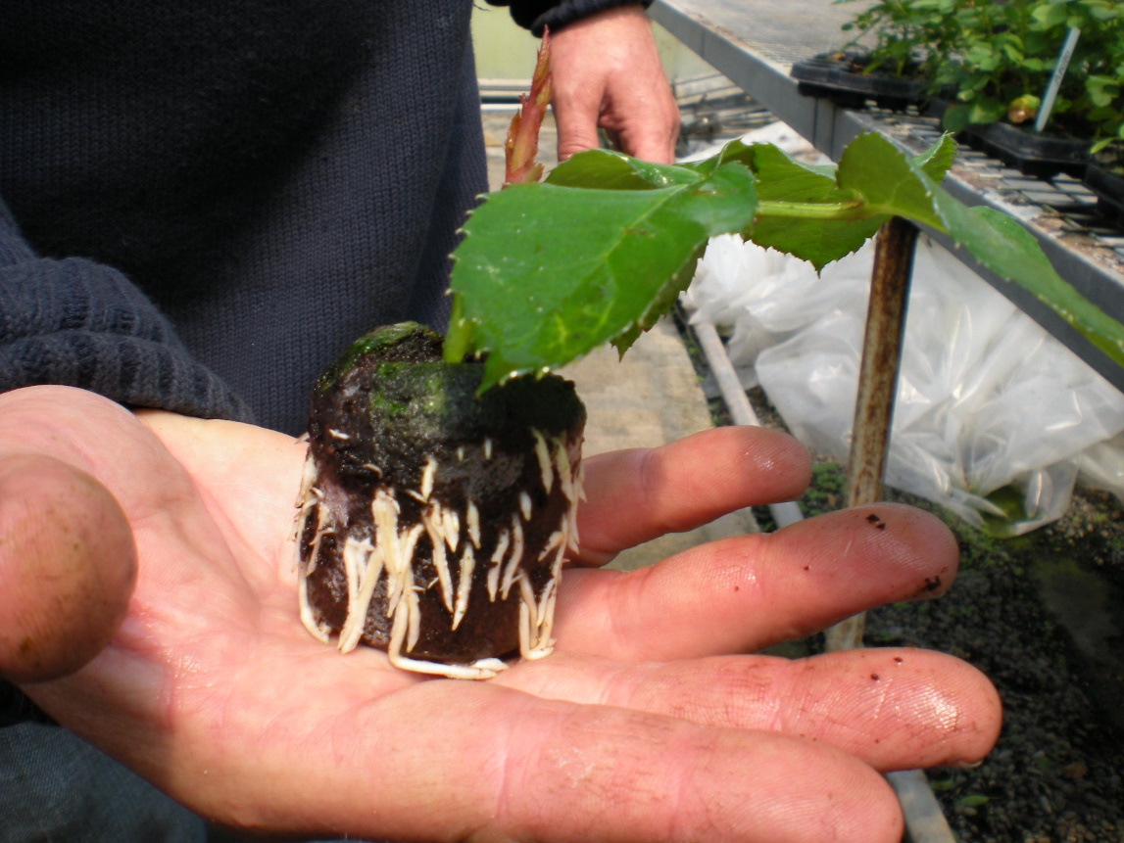

Rose cutting in Jiffy 7C showing root development

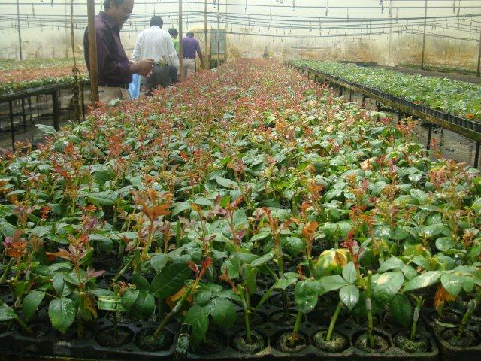

Roses in Jiffy deep trays

The following benefits were noticed:

- Ease of deployment and usage of Jiffy 7C pellets. Relatively simple process of hydrating and planting;
- Consistent, reproducible, growing media adhering to RHP specifications and ensuring a manageable and predictable outcome month after month;
- Improved rooting percentage, faster rooting and growth rates;
- Good tray system, making transport and management of the nursery easier;
- The Jiffy 7C pellet ensures the growing medium is contained in the 7C netting on removal from the tray. This enables easy transport to the greenhouse or when boxing and transporting to customers;
- Planting the whole pellet with plant ensures ease of transplant, reducing transplant shock.

Conclusion

The Jiffy 7C works well for propagating rose plants under African conditions. The client has been able to expand their business as a result of a constant supply of good plants to the greenhouse and in addition produce plants for sale. Not only has the Jiffy 7C proven itself when growing roses but also when transporting small plants and transplanting. This has enabled boxing and shipment of plants to customers.

