Tomato in Jiffy 7C case study

Customer

Customer was a hydroponic grower using an NFT system. A relatively new farmer, they were looking for an easier propagation method that made them independent of a seedling supplier and allowed them the flexibility to produce seedlings as and when they wanted. I addition they wanted a stable growing medium, reproducible crop after crop, without clogging their NFT system and with the low transplant shock afforded by the Jiffy 7C pellets.

Trial

A number of pellet sizes were trialled to find the ideal size that allowed for a relatively long seedling growth to ensure big plants could be transplanted into the system. Eventually a Jiffy 7C 40mmx45mm pellet was selected along with the Jiffy 40mm x60 cavity tray system. This tray system fitted into the ebb and flow system they used for their seedlings. The ebb and flow system worked extremely well with the Jiffy 7C system and after a short period of trialling a good hydration regime was established.

The seedlings were planted out into the NFT system after 2 weeks and the plants were then grown to maturity in the system.

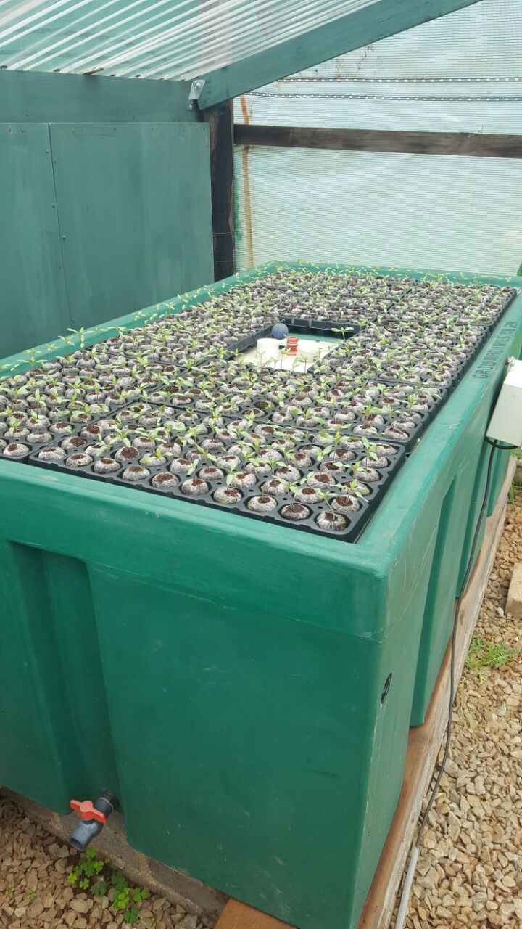

Tomato seedlings germinating in Jiffy 7C 40mmx45mm pellets in the ebb and flow system
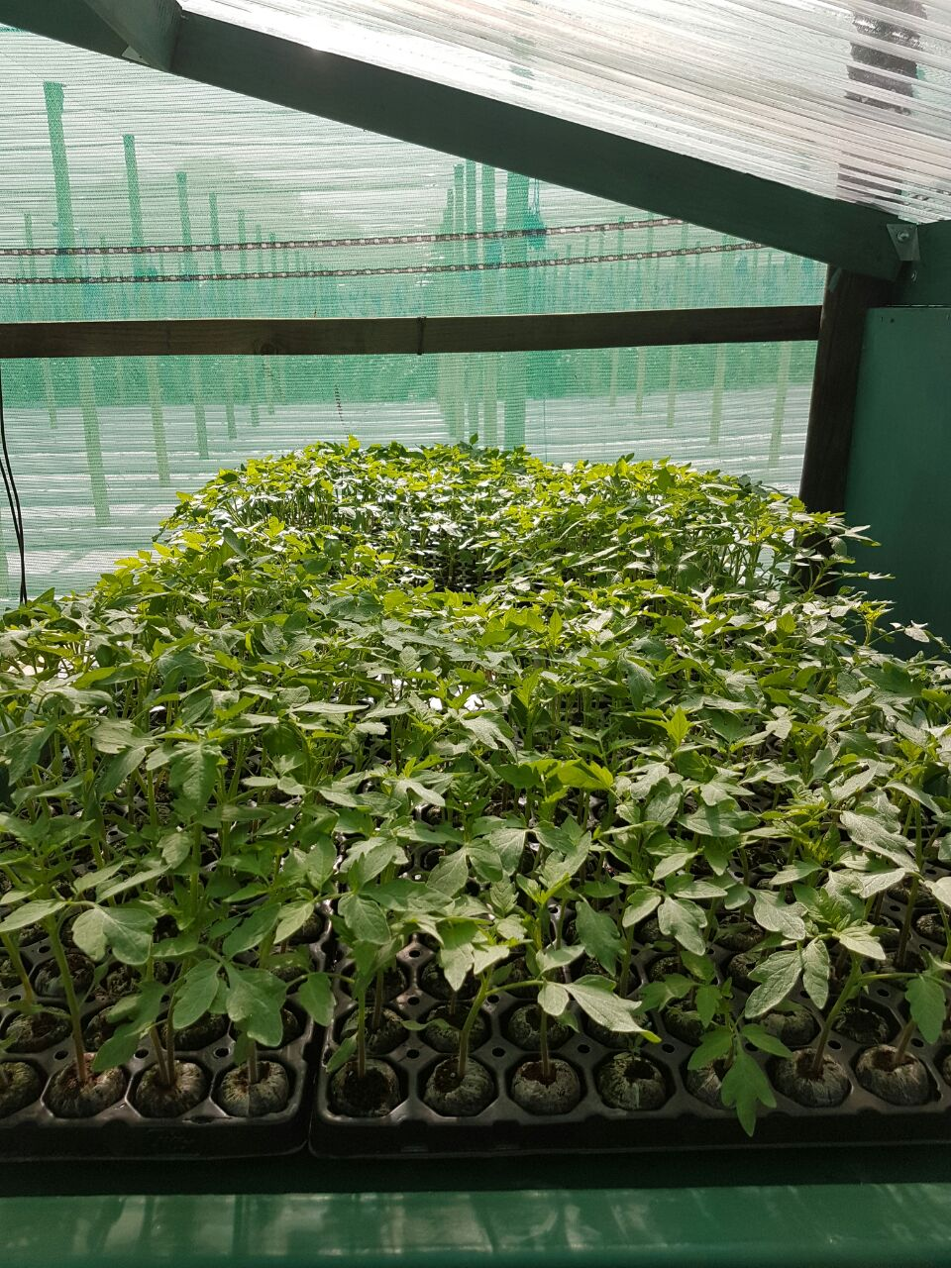

Tomato seedlings in ebb and flow system

Tomato seedling ready for transplant into NFT System

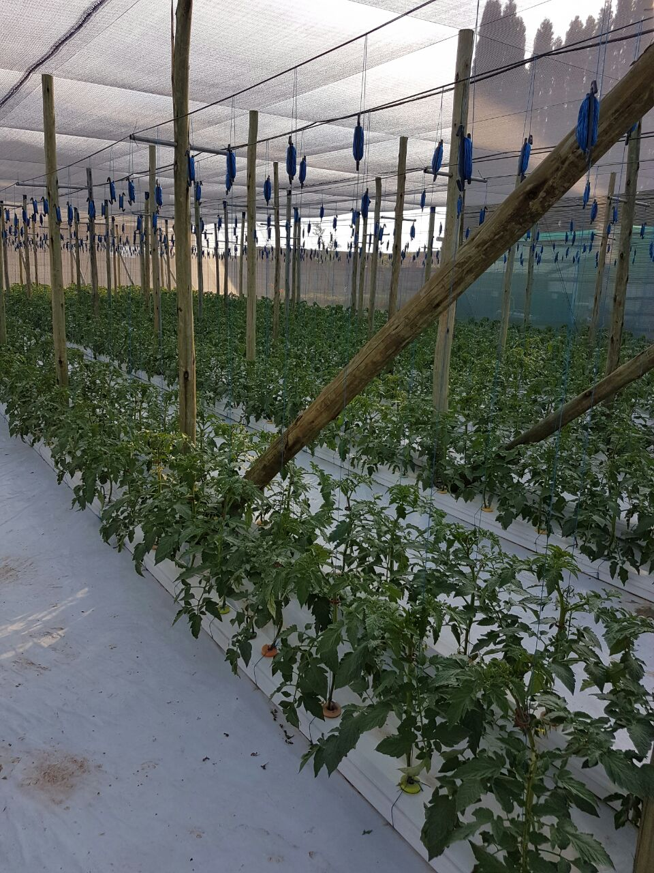
Tomato plants grown in Jiffy 7C in NFT system

Tomato plant roots in Jiffy 7C

A number of benefits were identified:

- Improved germination rate;
- Faster growth period from seeding to transplanting;
- Ease of transplant and vastly reduced transplant shock;
- Stable pellet form in the NFT system, providing a solid flat base that provides good exposure to the nutrient film;
- Very little clogging of the system as the growing medium is contained in the Jiffy 7C netting;
- Particularly strong rootmass resulting in healthy plants and better yields;

Conclusion

The Jiffy 7C pellet works well for tomatoes in an EFT system. The customer found it easy to propagate, grow, transplant and then grow to maturity using only the 7C as growing medium. The 7C tray and pellet system allows the grower the flexibility of growing their own seedlings how and when they want. The guaranteed reproduceability of every batch of Jiffy 7C pellets ensure consistent results, crop after crop and season after season.

