Tomatoes in Grow Blocks case study

The customer

An undercover tomato farmer who runs a well-established hydroponic tomato operation growing in greenhouses and using coco peat growbags as growing medium. He wished to optimise his production capacity by utilising growing time better.

In particular he wanted to grow his tomato plants to a maximum size before planting to ensure that fruiting occurred soon after transplanting in the system and resulting in less down time caused by smaller plants growing out before fruiting

Trial and roll out

A number of grow block sizes were trialled over a crop cycle until the Jiffy Grow block in 10cmx10cm x6.5cm (expanded dimensions) was settled on. This grow block provided enough size for significant root development and plant growth and also provided the stability for a fairly large plant to remain upright with a supporting rod inserted.

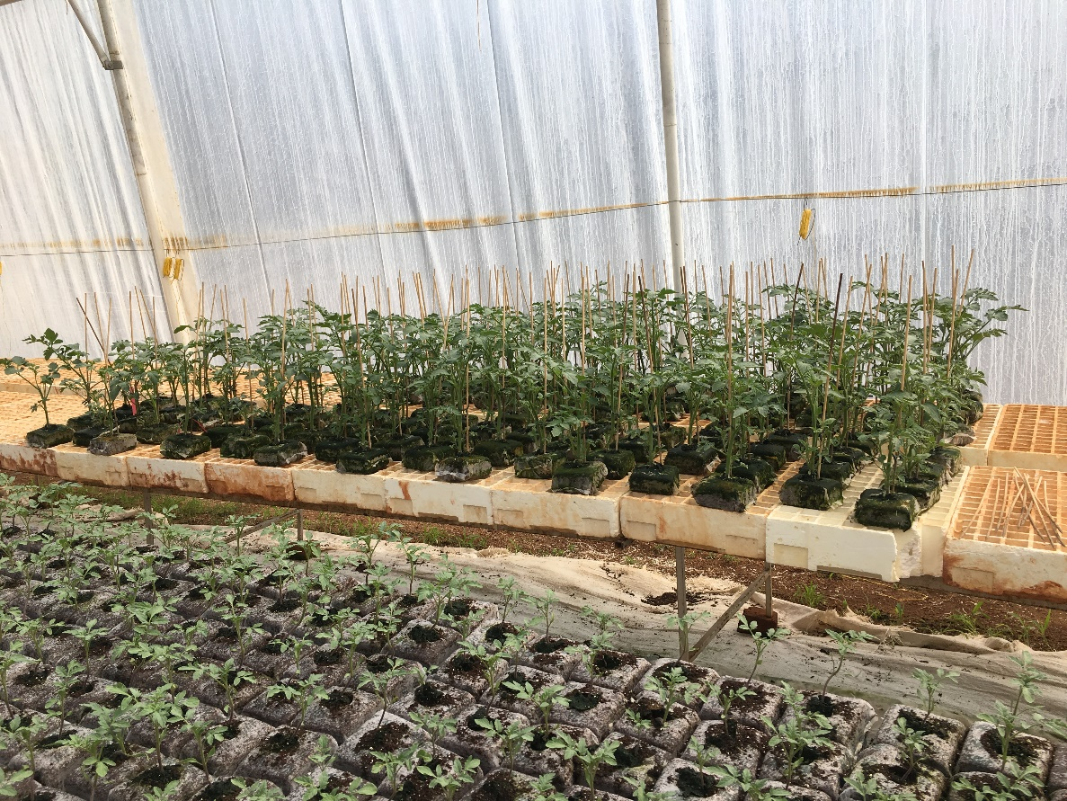

The following benefits were noticed:

- Rapid growth and exceptional root development in the RHP certified growing medium;
- Ability to grow the plants to a size where they are big enough to quickly grow on and fruit when they are transplanted into growbags, thereby reducing downtime in the greenhouse;
- Overall reduction in time from seeding to fruiting;
- Stable, robust grow blocks that do not need trays and can be deployed on the ground or on tables;
- Easily transportable from nursery to greenhouse;
- Quick grow through into growbags on transplant, no cutting of netting required, simply place on top of growbag;

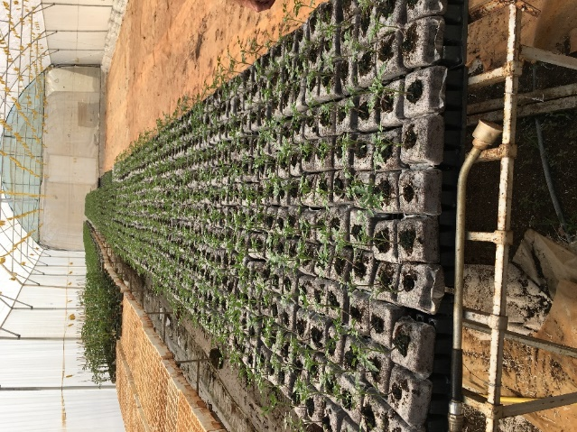

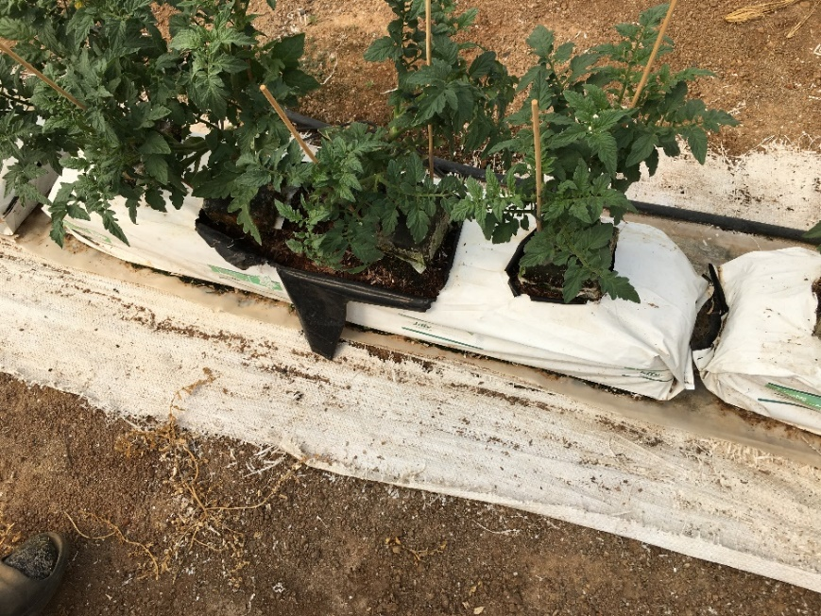
Tomatoes in growblocks placed on growbags.
Conclusion

The Jiffy grow blocks performed well and allowed the grower to optimise his production by utilising growing time better. The blocks allow him to decrease the dormant time the plants spend in the system before fruiting starts and allow him to control his crop better.

Consideration must be given to the space required for the grow blocks during the growing out phase.

